MULTI-PURPOSE E-CARD SYSTEM

AIM:
The objective of this project is to design multi-purpose E-Card system using RFID technology.

INSIGHT:
- Good knowledge of C-Programming.
- Knowledge of Embedded-C programming
- Thorough with the LPC2148 Architecture, General purpose I/O Interface
- Understanding of RFID usage.
- Understanding of I2C protocol.
- Understanding of LCD and KEYPAD.

BLOCK DIAGRAM:

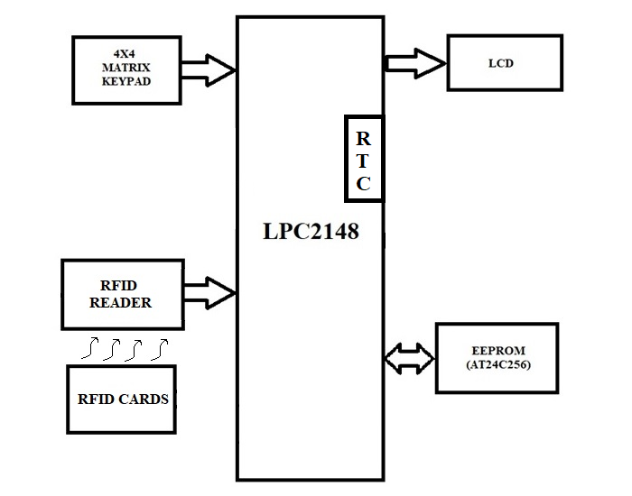
REQUIREMENTS:

HARDWRAE REQUIREMENTS:

- LPC 2148
- RFID Reader
- RFID cards
- 20x4 LCD
- 4x4 Matrix keypad
- AT24C256
- USB-UART Converter

SOFTWARE REQUIREMENTS:

- EMBEDDED C – PROGRAMMING
- KEIL-C COMPILER
- FLASH MAGIC

SEQUENCE TO BE FOLLOWED FOR IMPLEMENTATION:
- Create New Folder in your server/Laptop/PC and save that folder with your project name
- Individually can check each and every module.
- First check lcd to display character constant, string constant and integer constant.
- Next check keypad peripheral by displaying key values on LCD and design one function for password. This function will return true or false based on the password entry from user.
- Next check the UART peripheral to transmit character constant, string constant and integer constant and receive string constant using UART interrupts (download UART interrupts code from LMS).
- Next connect RFID reader to LPC2148 microcontroller then write logic for reading the RFID card information and display on LCD.
RFID reader will give the 10 bytes of data for each card. First character is start of the text (0x02), 8 bytes of card number and last character is end of the text (0x03).
If the card number is “12345678” then output of the RFID reader is 0x02, 0x31, 0x32, 0x33, 0x34, 0x35, 0x36, 0x37, 0x38, 0x03
Note: need to extract the only card number from this data
- After checking all individual interfacings then follow the below mentioned steps to complete the project.
- Display Project Name on LCD for some time.
- Then display “Waiting for card” String in 1st line on LCD
- Once the RFID card is placed in front of RFID reader then reader is sending the card number through serial communication with the help of 9600 baud rate.
- After reading the card number, display card number equivalent user name on lcd if card is valid otherwise display “invalid card” on LCD.
- If card is belonging to user card, then display below mentioned menu on LCD.
  - PAN CARD
  - ATM CARD
  - VOTING CARD
  - DRIVING LICENSE
  - EXIT
- From that menu, user has to select one option based on his/her requirement.
- If any one of the options is selected among first three, then need to enter the password to access that operation. If entered password is correct then required operation need to perform.
- If option 1 is selected, then display the user’s name, date of birth and pan card number on LCD for some time then control goes back to menu.
- If option 2 is selected, display the below mentioned menu on LCD.
  - Bal Enquiry
  - Withdrawn
  - Deposit
  - exit
- based on the selected option need to perform the operation. If bal enquiry is selected then read the user account balance from EEPROM from fixed location and display on LCD.
Note: for balance, need to take two memory locations
- if withdrawn option selected, then check the sufficient balance is available or not. If available then only do the process otherwise don’t process it.
Note: need to maintain the 500 rupees minimum balance.
- If deposit option is selected, then add the money to account. This option is just for demonstration purpose only.
Note: need to add required test cases according to real time process.
- If voting option is selected, first check the voting status of user. If voting is not done then display the below mentioned menu to allow user for voting.
- PARTY1 - SYMBOL
- PARTY2 - SYMBOL
- PARTY3 - SYMBOL
- PARTY4 – SYMBOL
- EXIT
Note: user has to select any one of the options. And user defined symbol is designed with the help of CGRAM concept.
For reference use the following keypad array.....

‘1’ | ‘2’ | ‘3’ | ‘4’
‘5’ | ‘6’ | ‘7’ | ‘8’
‘9’ | ‘0’ | ‘*’ | ‘#’
‘!’ | ‘@’ | ‘$’ | ‘&’
* -  # - | delete enter
- Based on the voter interest he/she has to select the one party which he/she has to vote.
- Here EEPROM is used to save the voting status of the user.
- if user is selected the 4th option, then display the user driving license information on LCD.
- Driving license information should be user name, Class of vehicle (two/four-wheeler), license validity, user address in short cut manner.
- To check the license validity, first read the current RTC information from the on-chip RTC and compare with the license last date. If it is valid then display the “valid license” on LCD or display “Invalid license. Please renew your license” on LCD.
Note: last date of driving license information needs to store in the code memory of LPC2148.
- If 5th option is selected then control goes back to menu.
- The above process for user card. If officer card is placed, then it is used for resetting the voting machine. After resetting the voting status, again user can utilize his/her vote.
- If you are getting this output then your project is completed.
******************************* ALL THE BEST **********************************

